Legacy Giving with Village Water
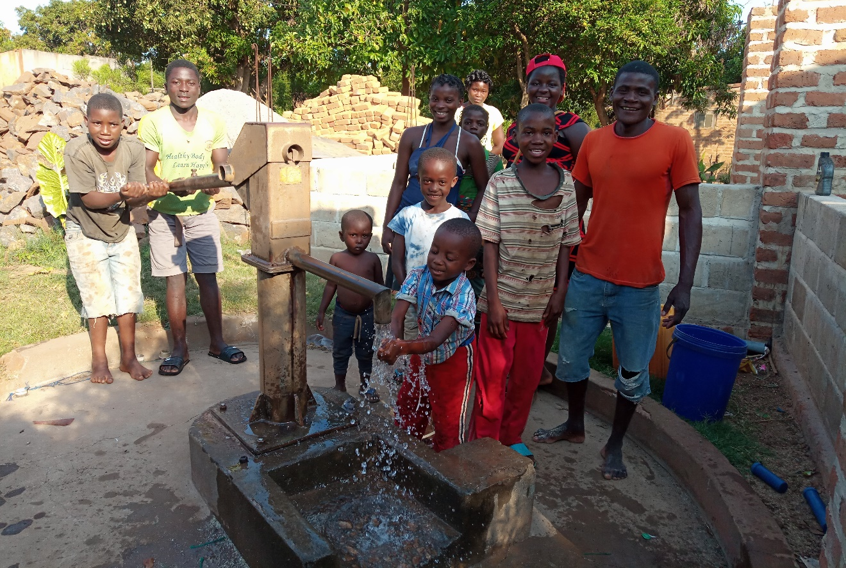
Why should I have a will?
Everyone needs to have a will in place. Without one you will not get to decide how your assets are divided, the process might take longer and cause difficulties for your family and might incur additional costs on your estate so it’s important you have one set up, regardless of whether you want to leave a legacy to us.
How do I leave a Legacy?
Find a solicitor you’re happy with. They will help guide you through the process, explain how you can leave a gift to Village Water as well as how you would like to divide the rest of your assets.
I already have a will, what should I do?
Your chosen solicitor can easily add Village Water to your will with a written instruction called a codicil. You just need to provide them with these details:
Village Water
c/o URC Office, Coleham Head, Shrewsbury, SY3 7BJ
Registered charity in England & Wales (1117377) and Scotland (SCO44129)
What should I leave?
Any gift you leave will make a long-lasting difference to our work and is an incredible way to support a cause you care about even after you have gone.
We have no suggested donation amount. We are incredibly grateful for any amount you choose to give.
What are the different types of gifts I can leave?
After taking care of your loved ones and any other affairs you can choose to leave Village Water either a:
Residuary legacy - a portion of what is left after all your other commitments have been met
Pecuniary legacy - a gift of a specific amount to Village Water
It is important to remember that you can change your mind at any time. You are always within your right to review and change your will.
What about Inheritance Tax?
Leaving a gift to a registered charity like Village Water can lower the Inheritance Tax payable on your estate, which could equate your loved ones to receive more. We recommend talking to your solicitor if you have more questions about Inheritance Tax.
Do I have to tell Village Water?
That decision is completely up to you. Of course, we would love the opportunity to say thank you but there is no obligation to let us know. If you prefer you can ask your solicitor to notify us.
Why should I leave a gift to Village Water?
Your will is completely personal to you. If you believe in the importance of water, sanitation, and hygiene education for every person everywhere, we can guarantee you will be making the right decision by leaving a legacy with us.
We have been working for 16 years to help reach communities with basic and life changing facilities – and we have supported over 500,000 people since we began. With your gift we can continue that work, to help children go to school, to help families protect themselves for disease, so parents can work and feed their children so the next generation in rural Africa can lead healthier, fairer lives full of opportunity.
You can leave that legacy.
What are the next steps?
- Speak to Beth at Village Water beth@villagewater or call 01743 241563
- Find your own solicitor from the online directory www.lawsociety.org.uk

